Rotation Around an Internal Axis

Definition
# Source: AI Source: Provided by: [Data Path: Persons Table -> ID Column: 1, Name_En Column: Motasem Essam] -> From: [ChatGPT] on [7/25/2026]
Rotation Around an Internal Axis is a method of generating a three-dimensional solid by rotating a two-dimensional plane region through an angle, usually ${360}^{∘}$, around a straight line that passes through the interior of the generating region.
The axis of revolution divides or passes through the generating region. During rotation, points of the region move along circular paths centered on the axis, producing a solid of revolution.
The resulting solid depends on:
- The geometric shape of the generating region.
- The position and direction of the internal axis.
- The dimensions of the generating region.
- The distance of each point from the axis.
- The angle of revolution.
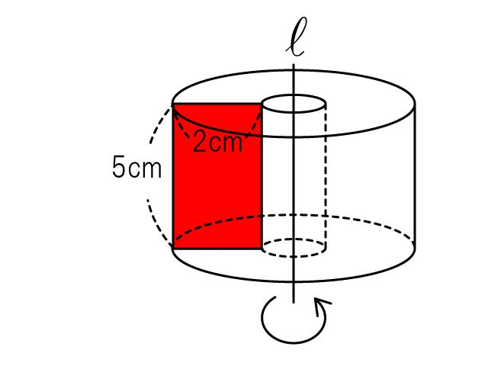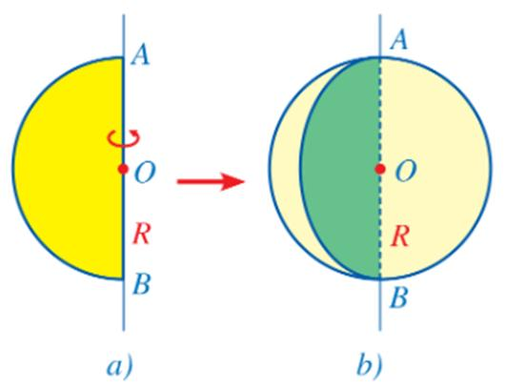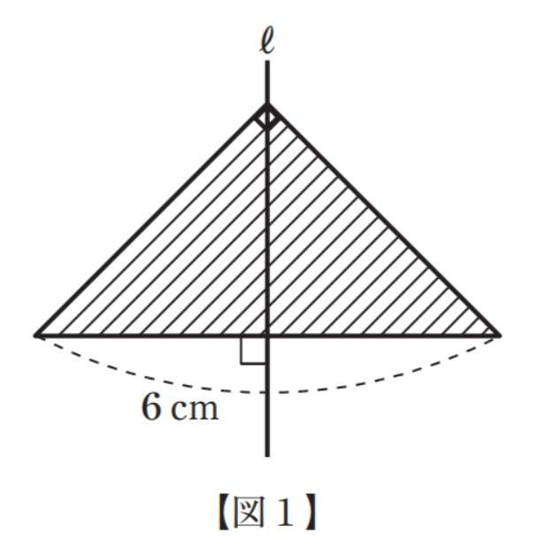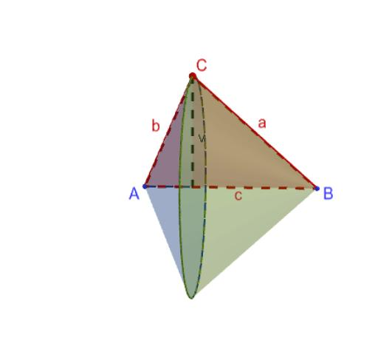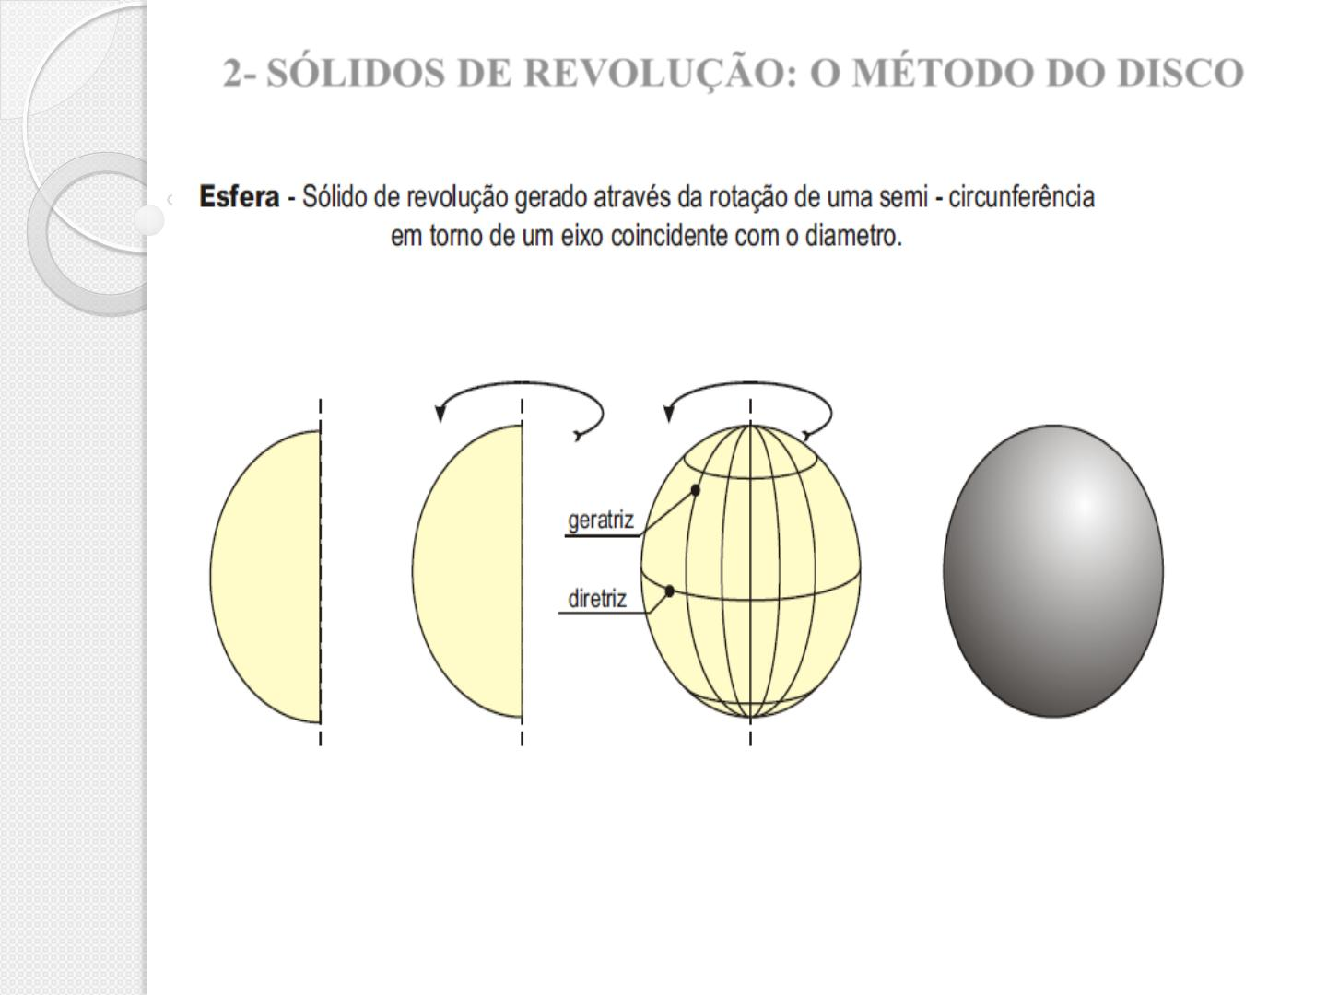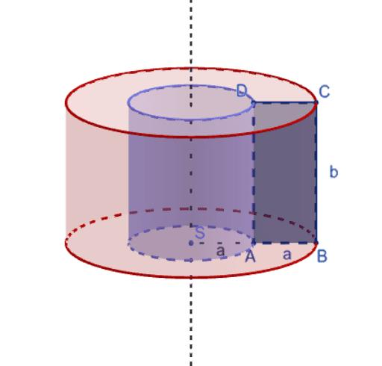

Geometric Structure
# Source: AI Source: Provided by: [Data Path: Persons Table -> ID Column: 1, Name_En Column: Motasem Essam] -> From: [ChatGPT] on [7/25/2026]
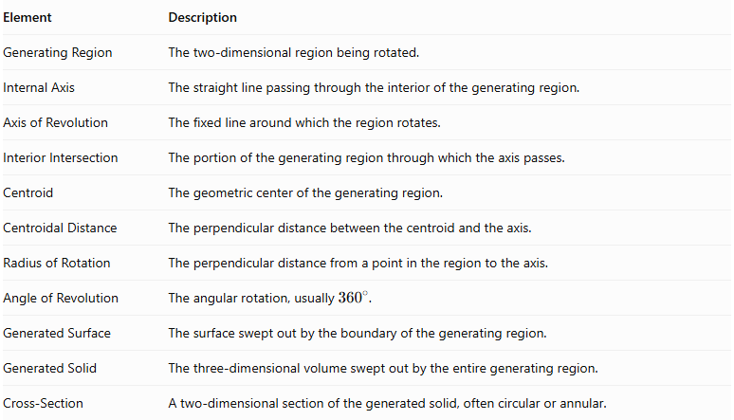
Element | Description
Generating Region | The two-dimensional region being rotated.
Internal Axis | The straight line passing through the interior of the generating region.
Axis of Revolution | The fixed line around which the region rotates.
Interior Intersection | The portion of the generating region through which the axis passes.
Centroid | The geometric center of the generating region.
Centroidal Distance | The perpendicular distance between the centroid and the axis.
Radius of Rotation | The perpendicular distance from a point in the region to the axis.
Angle of Revolution | The angular rotation, usually ${360}^{∘}$.
Generated Surface | The surface swept out by the boundary of the generating region.
Generated Solid | The three-dimensional volume swept out by the entire generating region.
Cross-Section | A two-dimensional section of the generated solid, often circular or annular.

Main Geometric Characteristics
# Source: AI Source: Provided by: [Data Path: Persons Table -> ID Column: 1, Name_En Column: Motasem Essam] -> From: [ChatGPT] on [7/25/2026]
- The axis passes through the interior of the generating region.
- The generating region intersects the axis.
- Points on the axis remain stationary during rotation.
- Points outside the axis trace circular paths around it.
- The generated solid generally has rotational symmetry around the axis.
- The resulting solid may be completely filled or may contain cavities, depending on the generating region.
- The generated cross-sections depend on the distance between the region's boundaries and the axis.

Types of Rotation Around an Internal Axis
# Source: AI Source: Provided by: [Data Path: Persons Table -> ID Column: 1, Name_En Column: Motasem Essam] -> From: [ChatGPT] on [7/25/2026]
Rotation around an internal axis can be classified according to the geometric shape of the generating region.

Rotation of a Rectangular Region Around an Internal Axis
# Source: AI Source: Provided by: [Data Path: Persons Table -> ID Column: 1, Name_En Column: Motasem Essam] -> From: [ChatGPT] on [7/25/2026]
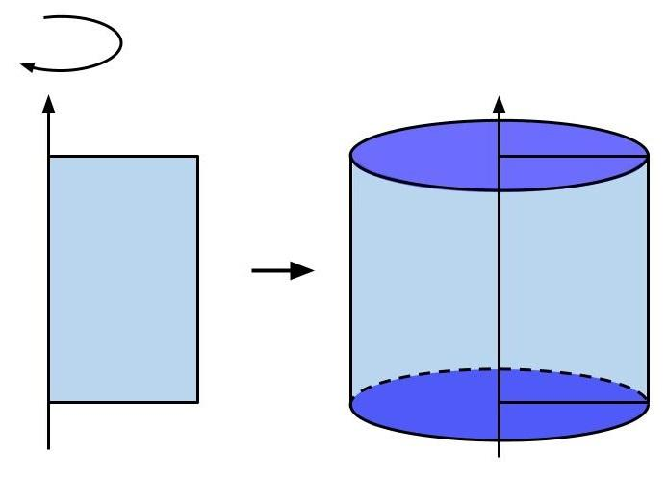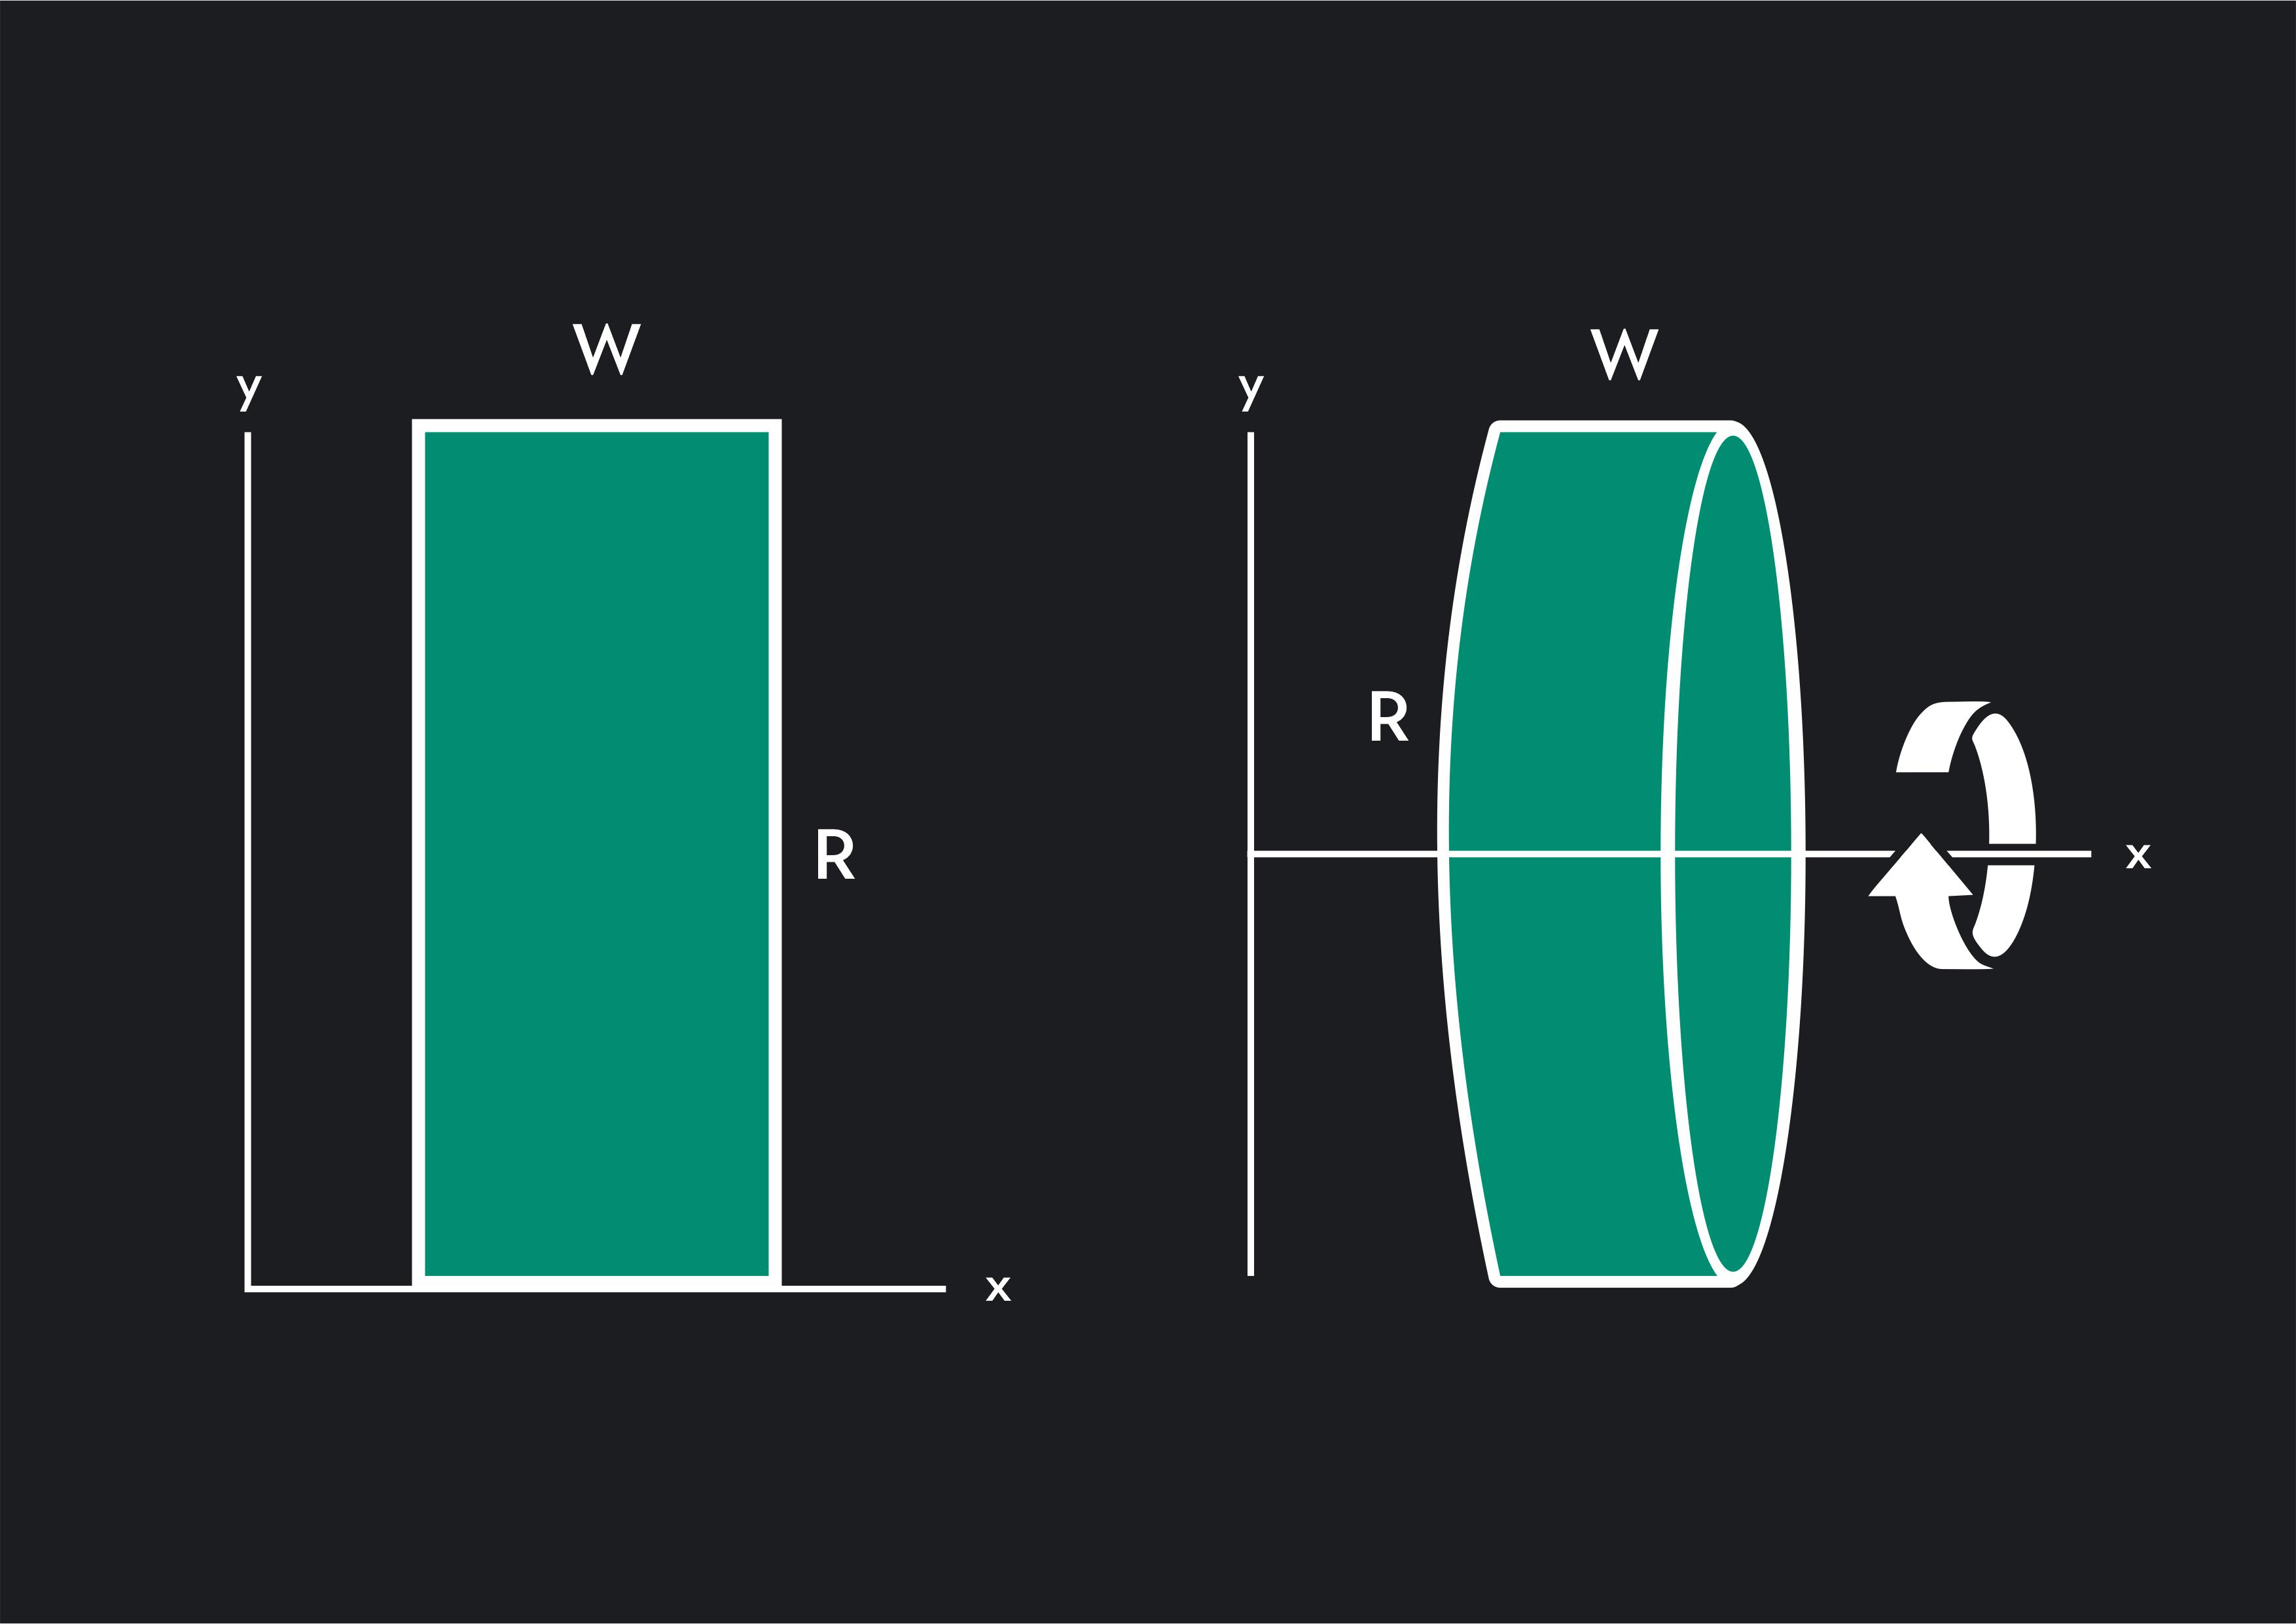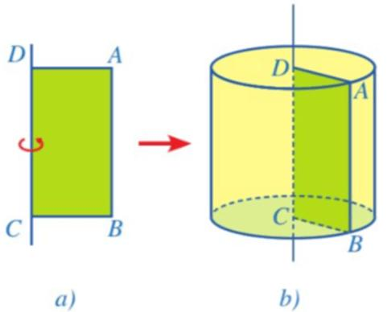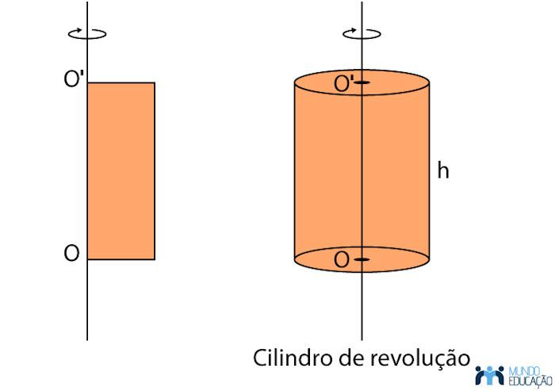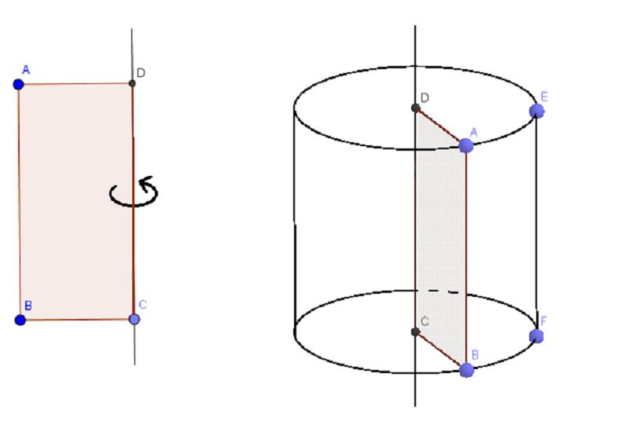
A rectangular region rotates around an internal axis parallel to one of its sides.
Generated Solid: Right Circular Cylinder, when the rectangle extends continuously from the axis to its opposite boundary.
Let:
- $r$ = perpendicular distance from the axis to the opposite side.
- $h$ = length of the rectangle parallel to the axis.
Volume:
$$V=πr^{2}h$$
Curved Surface Area:
$$S_{L}=2πrh$$
Total Surface Area:
$$S_{T}=2πr(r+h)$$
If the axis is positioned inside the rectangle but does not coincide with its central line, the generated cylinder's radius is determined by the greatest perpendicular distance from the axis to the rectangle's boundaries.

Rotation of a Triangular Region Around an Internal Axis
# Source: AI Source: Provided by: [Data Path: Persons Table -> ID Column: 1, Name_En Column: Motasem Essam] -> From: [ChatGPT] on [7/25/2026]
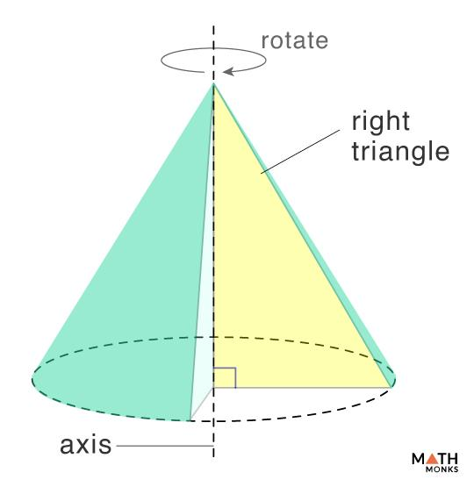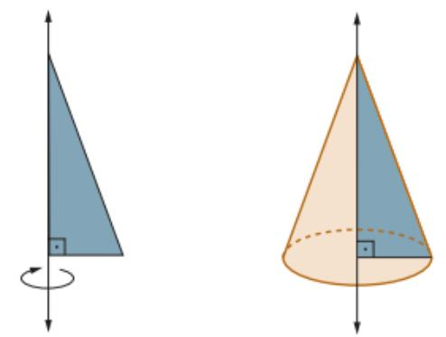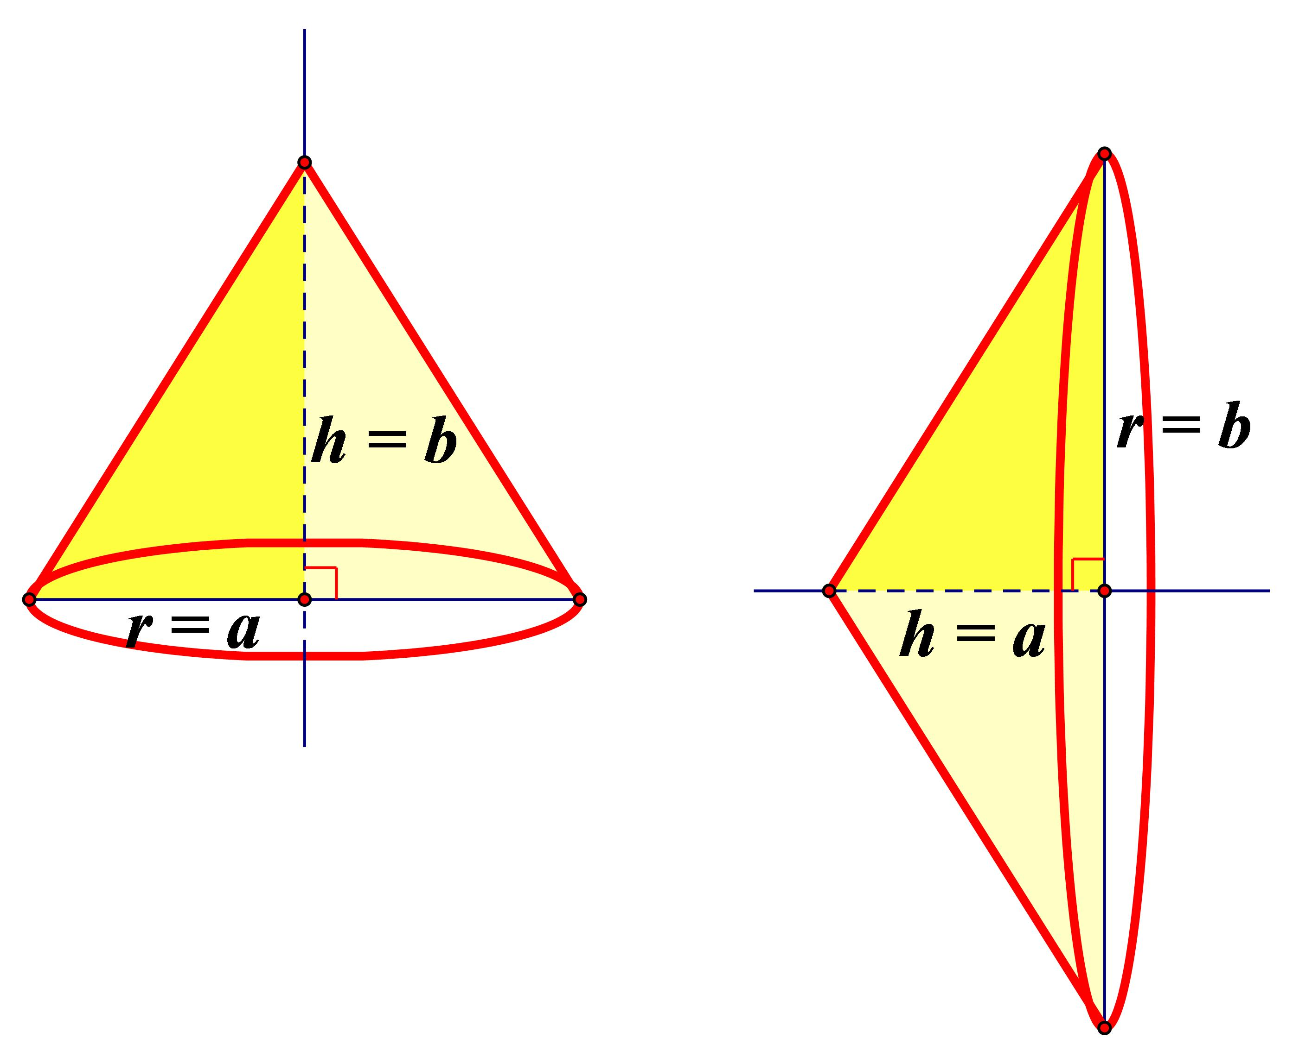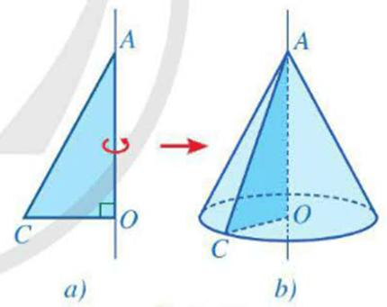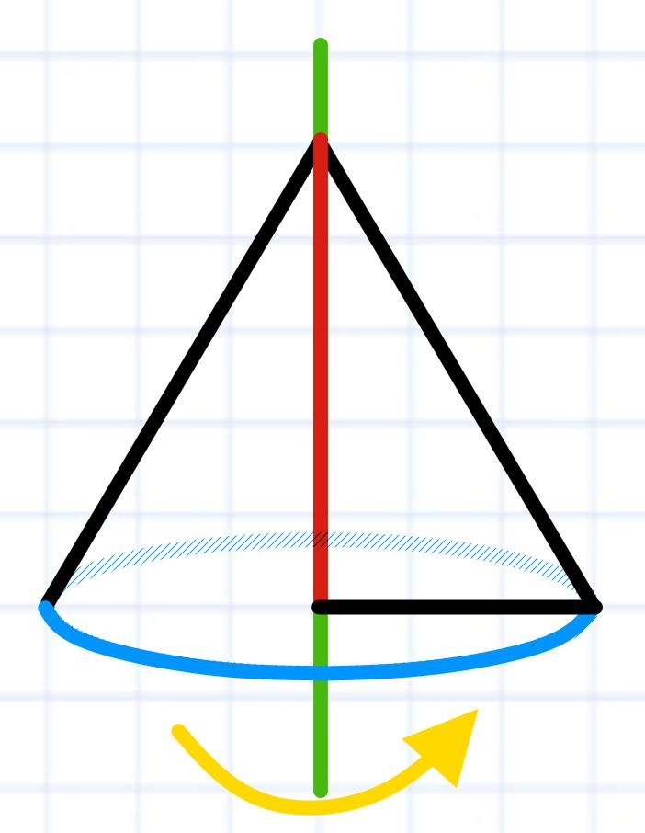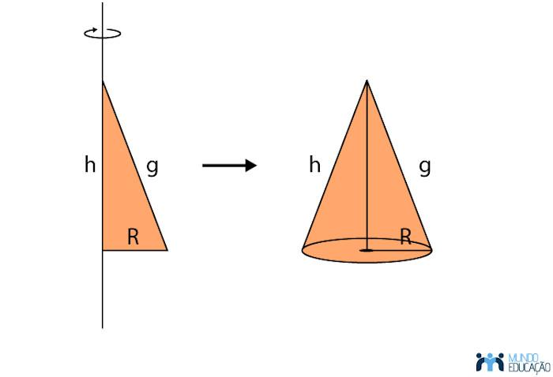
A triangular region rotates around an axis passing through its interior.
Depending on the axis position and orientation, the generated solid may have a conical or cone-like shape.
For example, rotating an isosceles triangular region around its altitude generates a right circular cone.
Let:
- $r$ = radius of the circular base.
- $h$ = height of the cone.
- $l$ = slant height.
Volume:
$$V=\frac{1}{3}πr^{2}h$$
Lateral Surface Area:
$$S_{L}=πrl$$
Total Surface Area:
$$S_{T}=πr(l+r)$$

Rotation of a Circular Region Around an Internal Axis
# Source: AI Source: Provided by: [Data Path: Persons Table -> ID Column: 1, Name_En Column: Motasem Essam] -> From: [ChatGPT] on [7/25/2026]
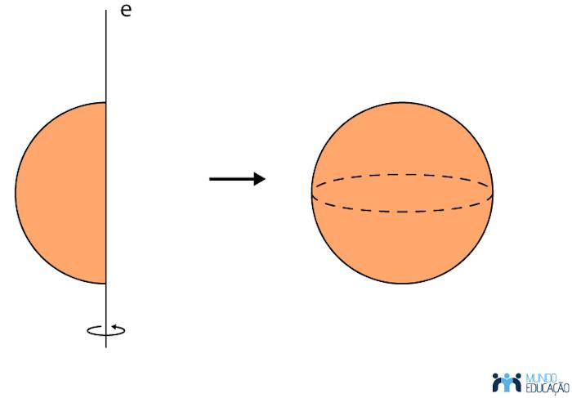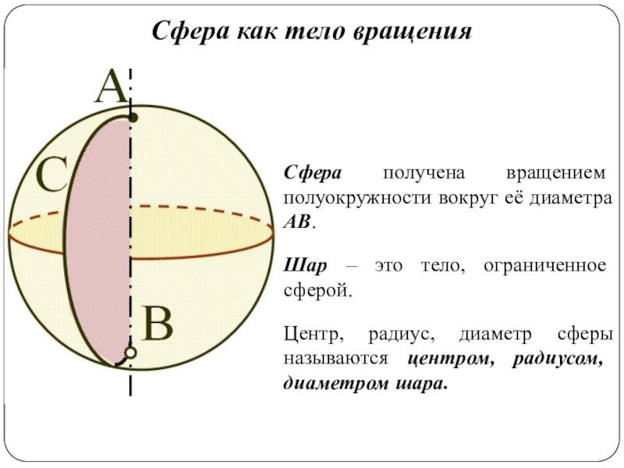
A circular region rotates around an internal axis that intersects its interior.
A particularly important case is when the axis coincides with a diameter of the circular region.
Generated Solid: Sphere.
Let $R$ be the radius of the generating circle.
Volume:
$$V=\frac{4}{3}πR^{3}$$
Surface Area:
$$S=4πR^{2}$$
When the axis is an internal line other than a diameter, the generated solid has a different shape and must be determined from the geometry of the region and the axis.

Rotation of a Semicircular Region Around an Internal Axis
# Source: AI Source: Provided by: [Data Path: Persons Table -> ID Column: 1, Name_En Column: Motasem Essam] -> From: [ChatGPT] on [7/25/2026]
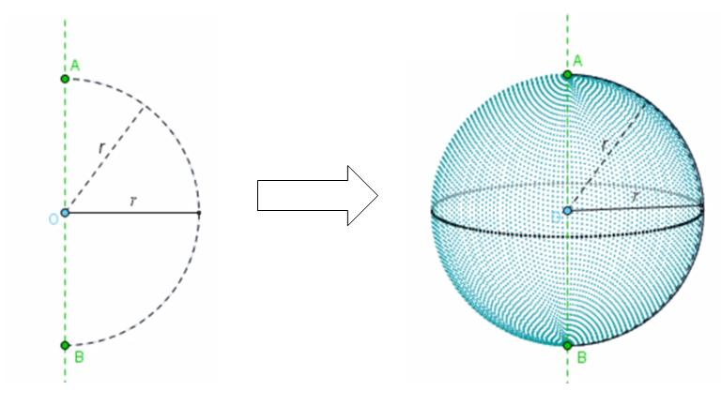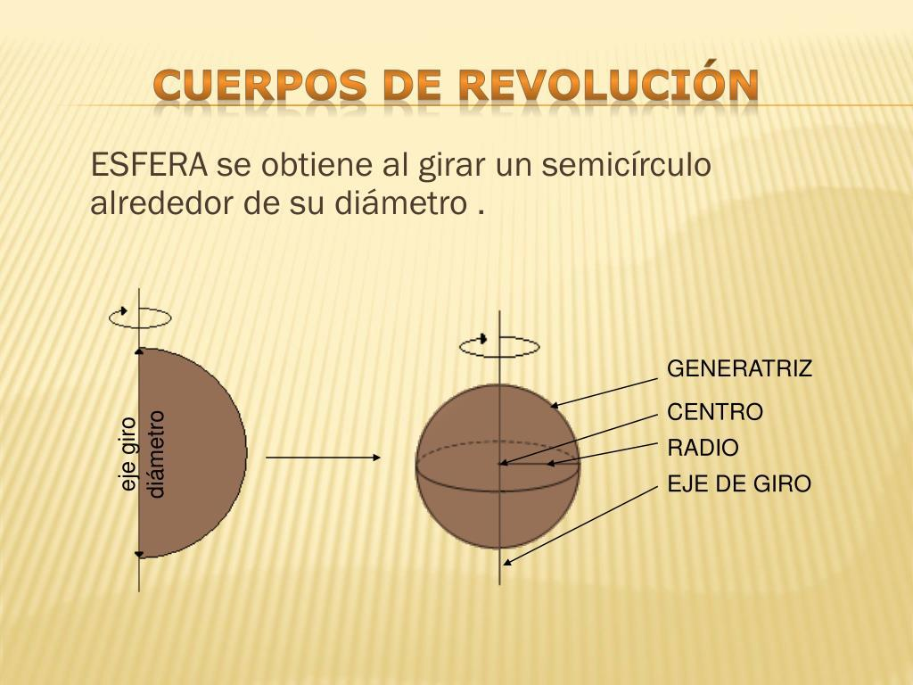
A semicircular region rotates around an axis that passes through its interior.
The resulting solid depends on the axis orientation.
For example, rotating a semicircular region around its symmetry axis, which passes through its interior and is perpendicular to its diameter, generates a sphere.
The generated solid is therefore determined by the relationship between the semicircle's curved boundary, diameter, and axis of revolution.

Rotation of an Elliptical Region Around an Internal Axis
# Source: AI Source: Provided by: [Data Path: Persons Table -> ID Column: 1, Name_En Column: Motasem Essam] -> From: [ChatGPT] on [7/25/2026]
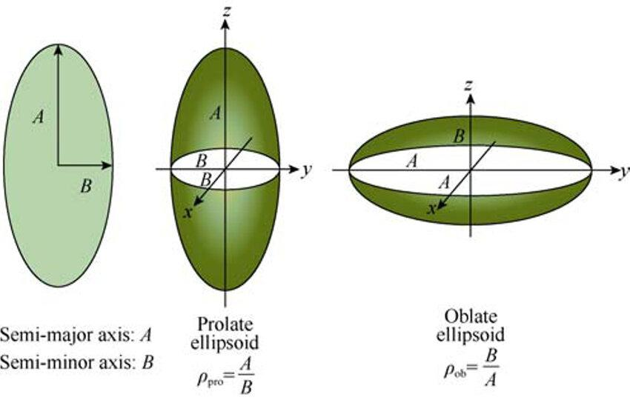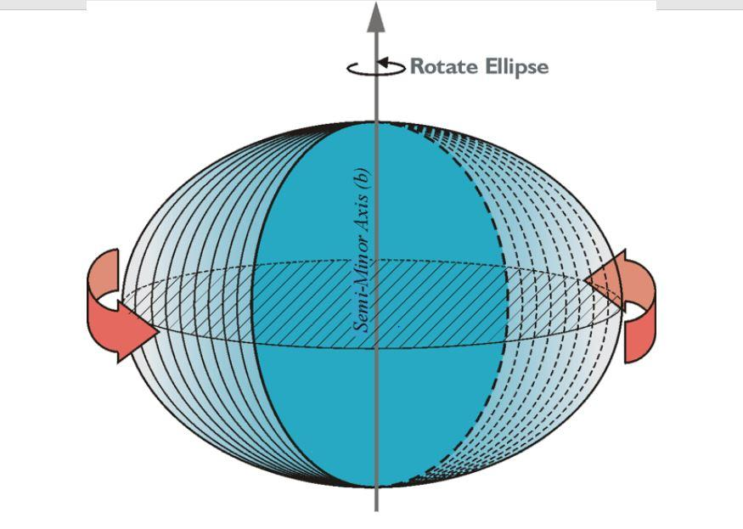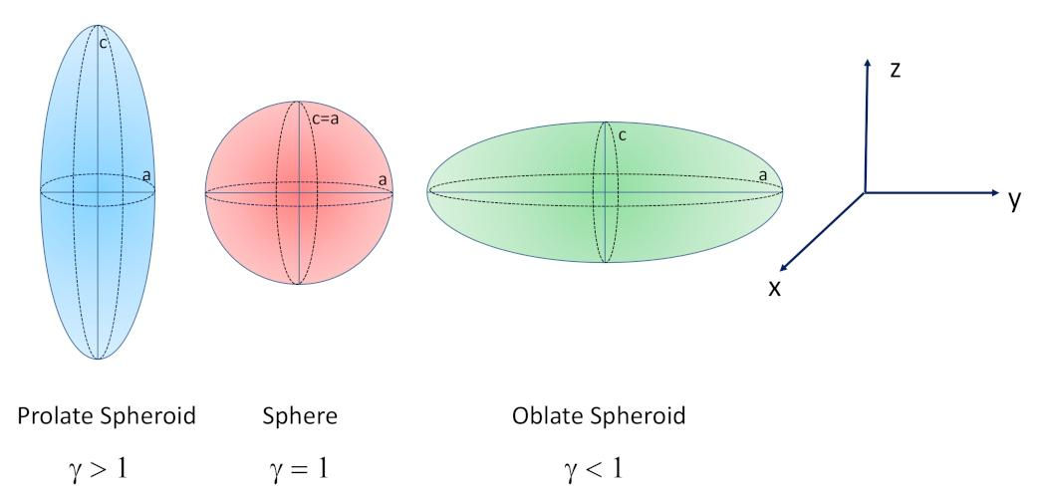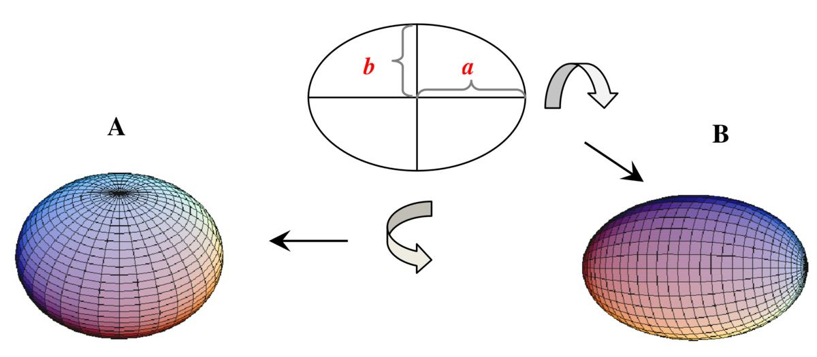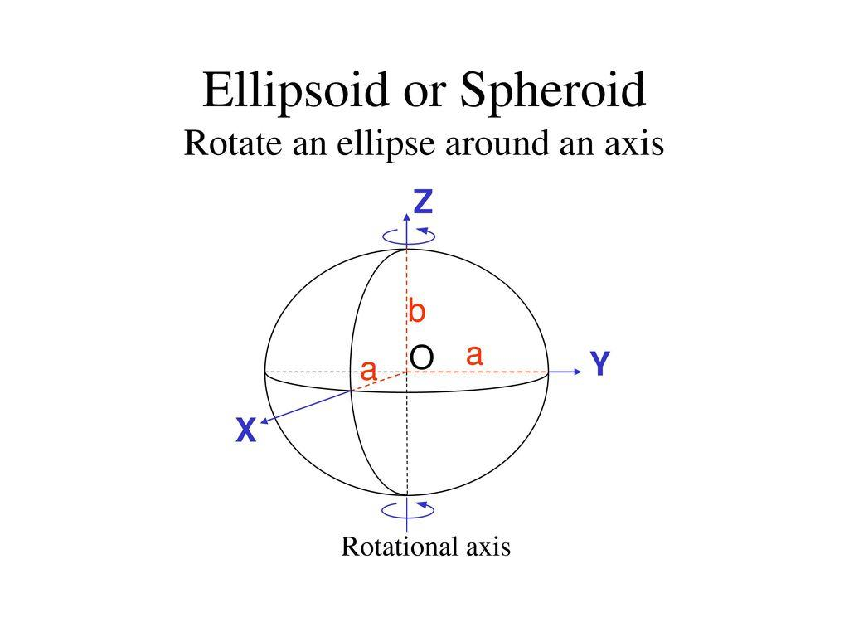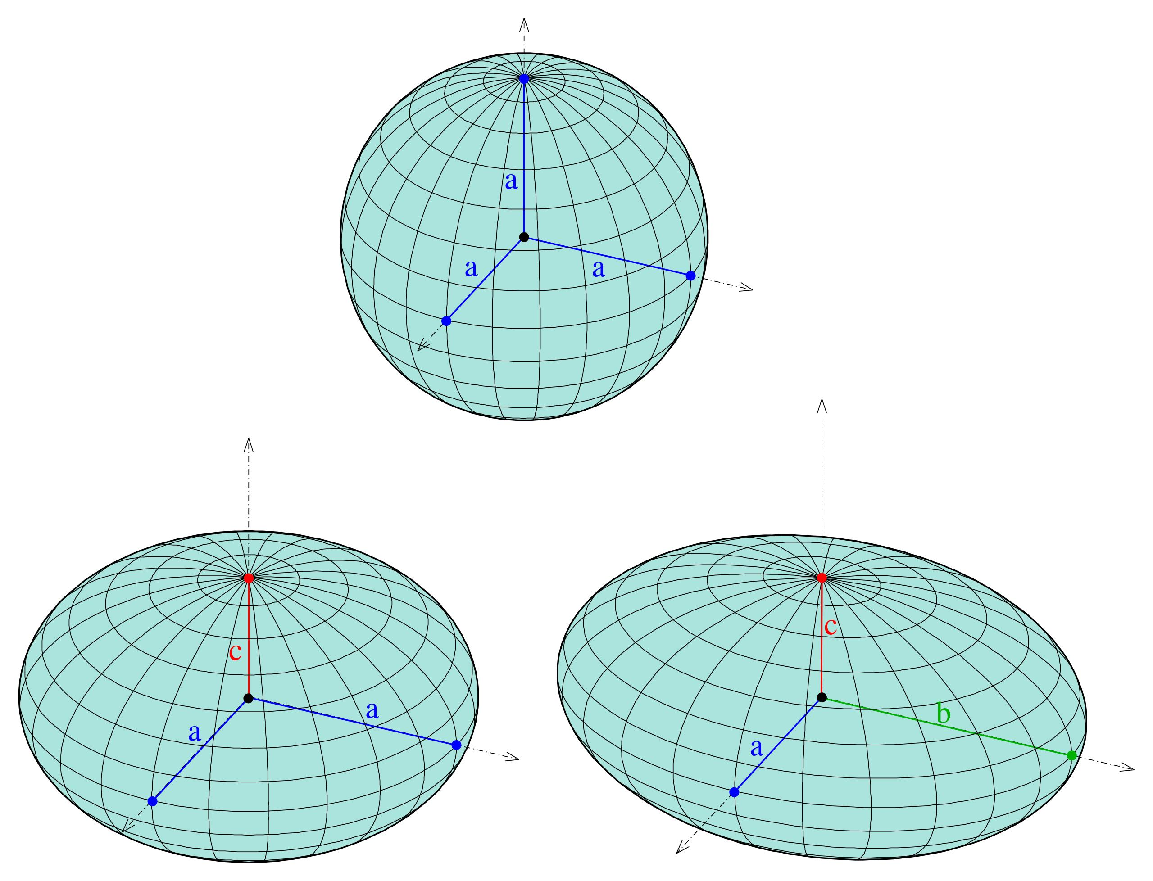
An elliptical region rotates around an internal axis passing through its interior.
Two important cases are:
A. Rotation Around the Major Axis
Generates a prolate spheroid.
$$V=\frac{4}{3}π{ab}^{2}$$
B. Rotation Around the Minor Axis
Generates an oblate spheroid.
$$V=\frac{4}{3}πa^{2}b$$
Where:
- $a$ = semi-major axis.
- $b$ = semi-minor axis.
If $a=b$, the resulting solid is a sphere.

Rotation of an Irregular Region Around an Internal Axis
# Source: AI Source: Provided by: [Data Path: Persons Table -> ID Column: 1, Name_En Column: Motasem Essam] -> From: [ChatGPT] on [7/25/2026]
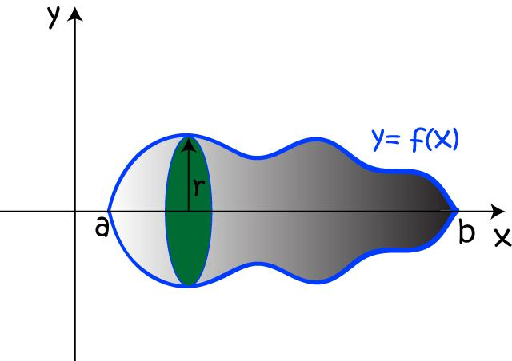
An irregular plane region rotates around an axis passing through its interior.
The resulting solid has a non-uniform rotational profile determined by the shape of the region and its position relative to the axis.
Its cross-sections may consist of disks, annular regions, or more complicated radial intervals.

Mathematical Representation

General Rotation Principle
# Source: AI Source: Provided by: [Data Path: Persons Table -> ID Column: 1, Name_En Column: Motasem Essam] -> From: [ChatGPT] on [7/25/2026]
For a point $P$ in the generating region, its distance from the axis determines the radius of its circular path.
For an axis along the $x$-axis:
$$r=|y|$$
For an axis along the $y$-axis:
$$r=|x|$$
For a general straight axis, the radius is the perpendicular distance between the point and that axis.

Disk Method
# Source: AI Source: Provided by: [Data Path: Persons Table -> ID Column: 1, Name_En Column: Motasem Essam] -> From: [ChatGPT] on [7/25/2026]
When a cross-section of the generating region extends from the axis to its outer boundary, rotating it produces a disk.
$$\boxed{V=π\int_{a}^{b}{R(x)^{2} dx}}$$
Where:
- $R(x)$ = disk radius.
- $a,b$ = integration limits.

Washer Method
# Source: AI Source: Provided by: [Data Path: Persons Table -> ID Column: 1, Name_En Column: Motasem Essam] -> From: [ChatGPT] on [7/25/2026]
When a cross-section produces an annular region, rotating it generates a washer.
$$\boxed{V=π\int_{a}^{b}{\left[R(x)^{2}-r(x)^{2}\right]dx}}$$
Where:
- $R(x)$ = outer radius.
- $r(x)$ = inner radius.

Cylindrical Shell Method
# Source: AI Source: Provided by: [Data Path: Persons Table -> ID Column: 1, Name_En Column: Motasem Essam] -> From: [ChatGPT] on [7/25/2026]
When the generating region is divided into strips parallel to the axis, rotation produces cylindrical shells.
$$\boxed{V=2π\int_{a}^{b}{ρ(x)h(x)} dx}$$
Where:
- $ρ(x)$ = distance from the strip to the axis.
- $h(x)$ = height or length of the strip.
The disk, washer, and shell methods are standard techniques for calculating volumes of solids of revolution.

Mathematical Properties
# Source: AI Source: Provided by: [Data Path: Persons Table -> ID Column: 1, Name_En Column: Motasem Essam] -> From: [ChatGPT] on [7/25/2026]
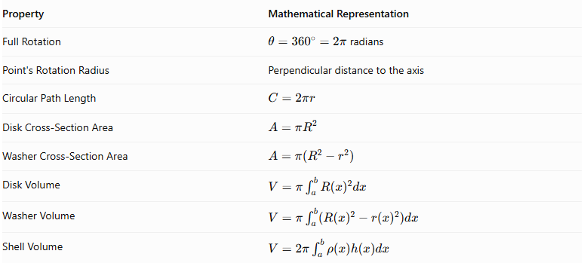
Property | Mathematical Representation
Full Rotation | $θ={360}^{∘}=2π$ radians
Point's Rotation Radius | Perpendicular distance to the axis
Circular Path Length | $$C=2πr$$
Disk Cross-Section Area | $$A=πR^{2}$$
Washer Cross-Section Area | $$A=π(R^{2}-r^{2})$$
Disk Volume | $$V=π\int_{a}^{b}{R(x)^{2}dx}$$
Washer Volume | $$V=π\int_{a}^{b}{(R(x)^{2}-r(x)^{2})dx}$$
Shell Volume | $$V=2π\int_{a}^{b}{ρ(x)h(x)dx}$$

Geometric Applications
# Source: AI Source: Provided by: [Data Path: Persons Table -> ID Column: 1, Name_En Column: Motasem Essam] -> From: [ChatGPT] on [7/25/2026]
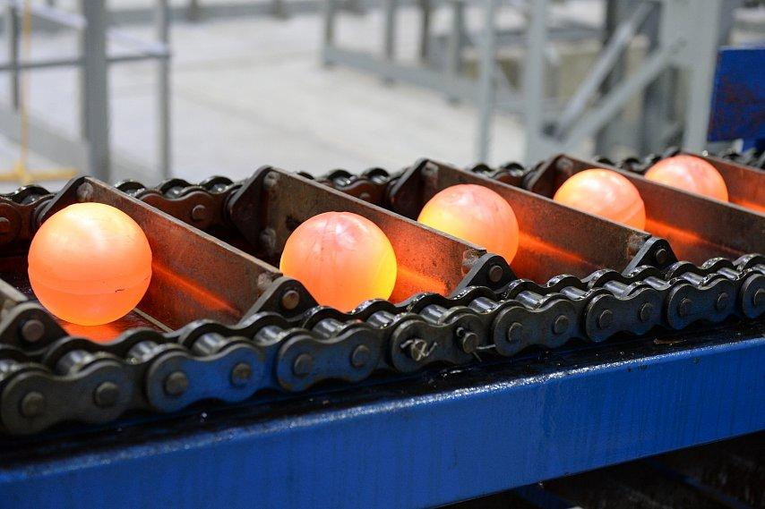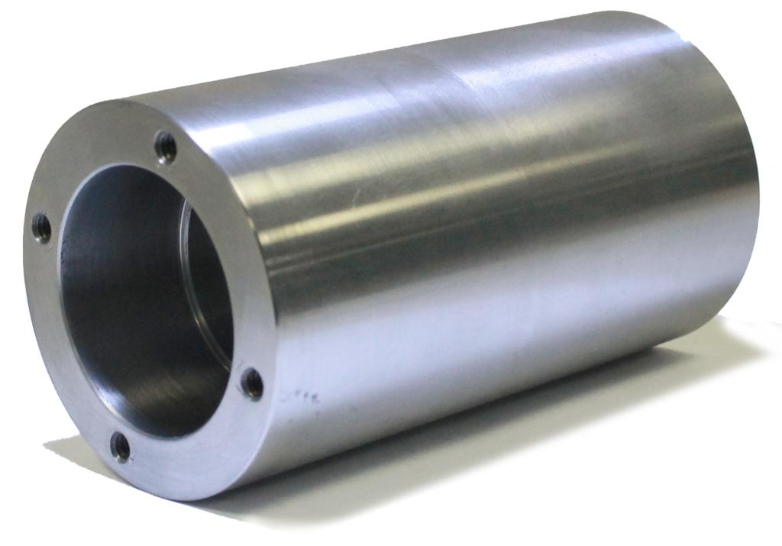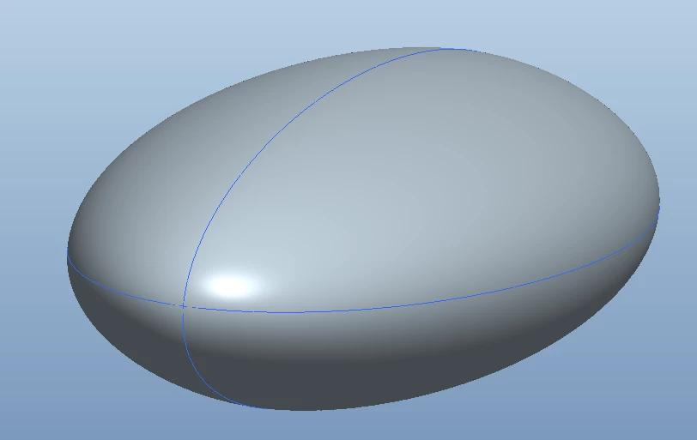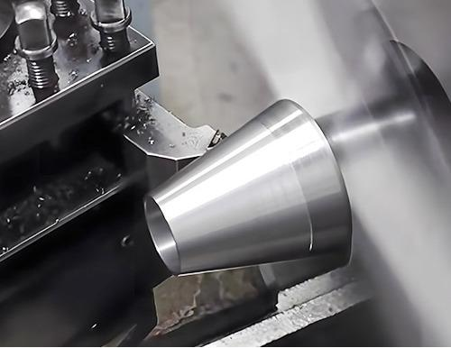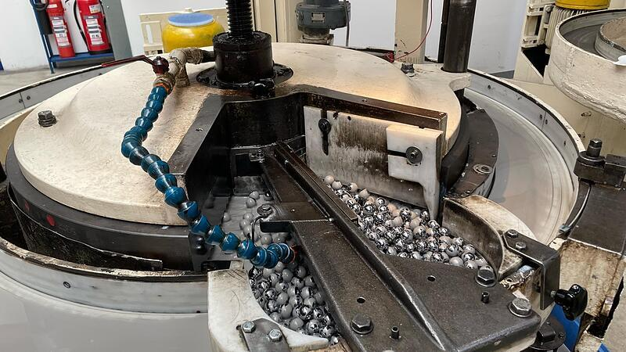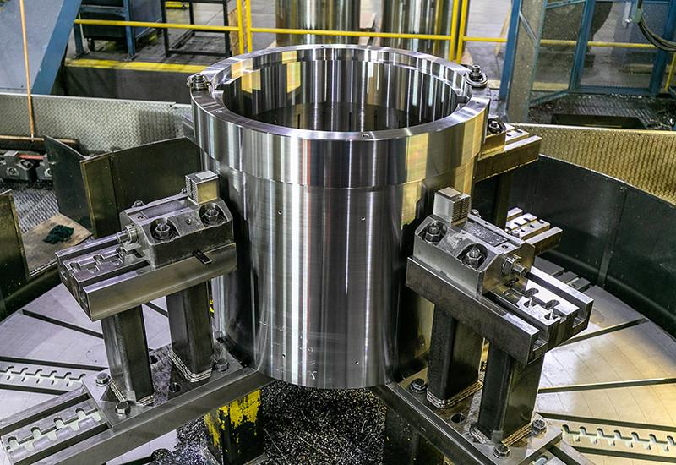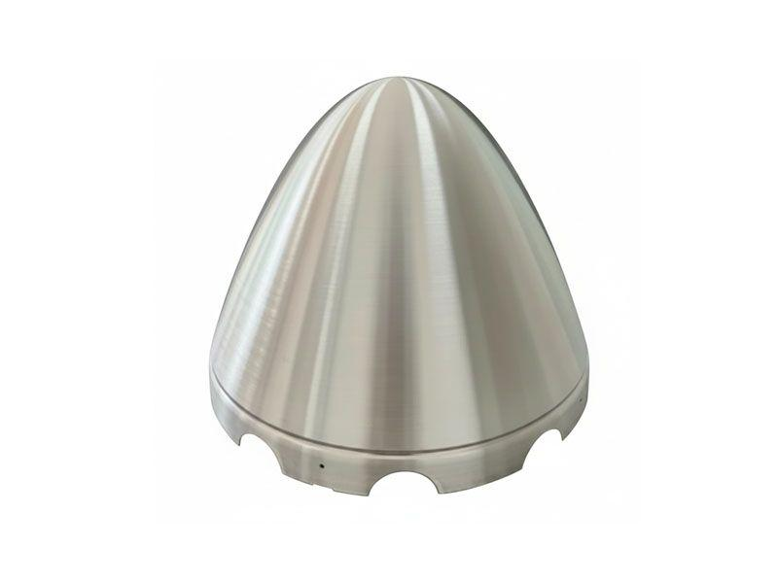
- Mechanical Engineering: Manufacturing cylindrical, conical, and spherical components.
- Industrial Manufacturing: Producing rotational parts using turning and machining processes.
- Architecture: Designing rotationally symmetric structures.
- Aerospace Engineering: Designing spheroidal and other rotational components.
- Mathematical Modeling: Studying volumes, surfaces, and cross-sections of rotational solids.

Comparison with Other Axis Positions
# Source: AI Source: Provided by: [Data Path: Persons Table -> ID Column: 1, Name_En Column: Motasem Essam] -> From: [ChatGPT] on [7/25/2026]
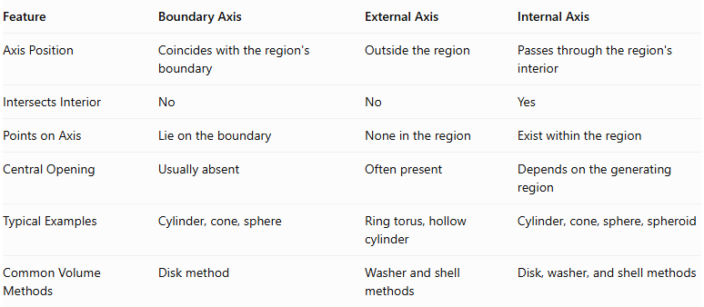
Feature | Boundary Axis | External Axis | Internal Axis
Axis Position | Coincides with the region's boundary | Outside the region | Passes through the region's interior
Intersects Interior | No | No | Yes
Points on Axis | Lie on the boundary | None in the region | Exist within the region
Central Opening | Usually absent | Often present | Depends on the generating region
Typical Examples | Cylinder, cone, sphere | Ring torus, hollow cylinder | Cylinder, cone, sphere, spheroid
Common Volume Methods | Disk method | Washer and shell methods | Disk, washer, and shell methods

Main Classification
# Source: AI Source: Provided by: [Data Path: Persons Table -> ID Column: 1, Name_En Column: Motasem Essam] -> From: [ChatGPT] on [7/25/2026]
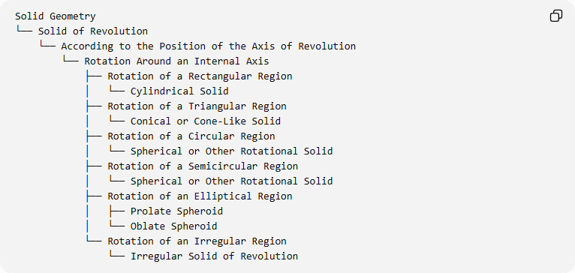
Solid Geometry
└── Solid of Revolution
└── According to the Position of the Axis of Revolution
└── Rotation Around an Internal Axis
├── Rotation of a Rectangular Region
│ └── Cylindrical Solid
├── Rotation of a Triangular Region
│ └── Conical or Cone-Like Solid
├── Rotation of a Circular Region
│ └── Spherical or Other Rotational Solid
├── Rotation of a Semicircular Region
│ └── Spherical or Other Rotational Solid
├── Rotation of an Elliptical Region
│ ├── Prolate Spheroid
│ └── Oblate Spheroid
└── Rotation of an Irregular Region
└── Irregular Solid of Revolution

Key Points
# Source: AI Source: Provided by: [Data Path: Persons Table -> ID Column: 1, Name_En Column: Motasem Essam] -> From: [ChatGPT] on [7/25/2026]
- Rotation around an internal axis occurs when the axis passes through the interior of the generating region.
- Points located on the axis remain stationary during rotation.
- Points away from the axis move along circular paths.
- The resulting solid may be a cylinder, cone, sphere, spheroid, or another rotational solid.
- The generated cross-sections can be disks or washers, depending on the region's geometry.
- The disk, washer, and cylindrical shell methods can be used to calculate the volume.
- The shape of the generated solid depends on both the generating region and the position of the axis.

Conclusion
# Source: AI Source: Provided by: [Data Path: Persons Table -> ID Column: 1, Name_En Column: Motasem Essam] -> From: [ChatGPT] on [7/25/2026]
Rotation Around an Internal Axis is a classification of solids of revolution based on an axis that passes through the interior of the generating region. Rotating different plane regions around such an axis produces various three-dimensional solids, including cylinders, cones, spheres, and spheroids.
The generated solid depends on the shape of the region, the position and direction of the axis, and the distances between the region's boundaries and the axis. The disk, washer, and cylindrical shell methods provide mathematical approaches for determining the volume of these solids.

Sources
# Source: AI Source: Provided by: [Data Path: Persons Table -> ID Column: 1, Name_En Column: Motasem Essam] -> From: [ChatGPT] on [7/25/2026]
- Ohio State University – What Is a Solid of Revolution?.
- Ohio State University – Solids of Revolution.
- OpenStax – Determining Volumes by Slicing.
- APEX Calculus – Disk and Washer Methods.

